**Week 1 –**

Compute the total cost of building a data center that houses 10 ExaBytes of HDD.

Factors to consider –

HDDs, networking, racks, building (real-estate),

power, cooling etc

HDD – 34 million $

Racks – 1.5 million $

Land – 6,560 $

**HDDs ( Hard Disk Drive ) –**

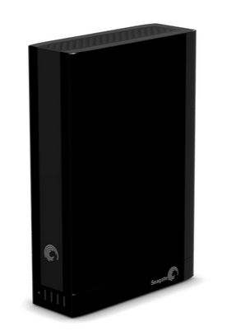

Seagate Expansion Desktop 4TB External Hard Drive – 128 $ X 2,62, 144

( Price per unit X quantity )

33,554,432 $

33.5 – 34 million $

10 Exa Bytes = 4 X 2,62, 144TB

# Racks –

# 

# Sans Digital HDDRACK 5 Bay Hard Drive Rack - 3.5", IDE, SATA 29 $ X 52,429

# 1,520,441 $

# 1.5 million $

# ( includes 4.7" cooling fan and a hollow aluminum frame for heat dissipation )

Each rack fits 5 hard disks.

Therefore, number of racks required = 52,429

**Land –**

Each rack take up about 3.5" + 1" space.

Total area = 52,429 X 4.5" = 235 930.5 sq inches = 1638.40278 sq foot

Avg price per sq foot for business in Buffalo - ~ 4 $ / sq ft / year

6,560 $

**Week 2 –**

HDD – 40 million $

Networking – 55 million $

Racks – 1.5 million $

Land – 10,000 $

**HDDs ( Hard Disk Drive ) –**

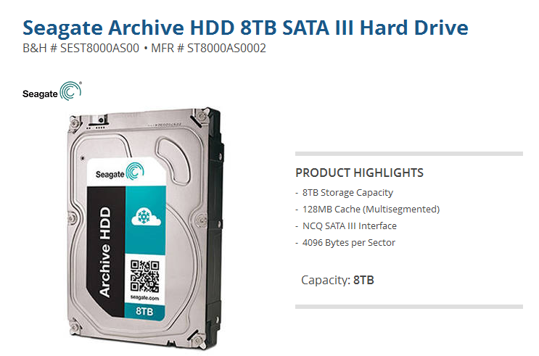

**Seagate Archive HDD 8TB SATA III Hard Drive** – 299 $ X 1,31,072

( Price per unit X quantity )

39,190,528 $

40 million $

10 Exa Bytes = 8 TB X 1,31,072

**Networking -**

A **network switch** (also called **switching hub**, **bridging hub**, officially **MAC bridge** ) is a [computer networking device](http://en.wikipedia.org/wiki/Computer_networking_device) that connects devices together on a [computer network](http://en.wikipedia.org/wiki/Computer_network), by using [packet switching](http://en.wikipedia.org/wiki/Packet_switching) to receive, process and forward data to the destination device. Unlike less advanced [network hubs](http://en.wikipedia.org/wiki/Network_hub), a network switch forwards data only to one or multiple devices that need to receive it, rather than broadcasting the same data out of each of its ports.

[ Source – Wikipedia ]

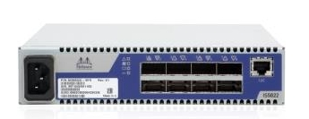

**Mellanox InfiniScale IV IS5022 QDR InfiniBand Switch – 1665.99 $ X 32,768**

( Price per unit X quantity )

54,591,160.32

55 million $

**1,31,072 X 2 = 2,62,144**

**( HDD units ) ( 2 ports per unit ) ( ports )**

**2,62,144 / 8 = 32,768**

**( ports ) ( ports per switch ) ( switches )**

# Racks –

# 

# Sans Digital HDDRACK 5 Bay Hard Drive Rack - 3.5", IDE, SATA 29 $ X 52,429

# 1,520,441 $

# 1.5 million $

# ( includes 4.7" cooling fan and a hollow aluminum frame for heat dissipation )

Each rack fits 5 hard disks.

Therefore, number of racks required = 52,429

**Land –**

Each rack take up about 3.5" + 3" space.

Total area = 52,429 X 6.5" = 340 788.5 sq inches = 2366.58680 sq foot

Avg price per sq foot for business in Buffalo - ~ 4 $ / sq ft / year

9,468 $

~ 10,000 $